[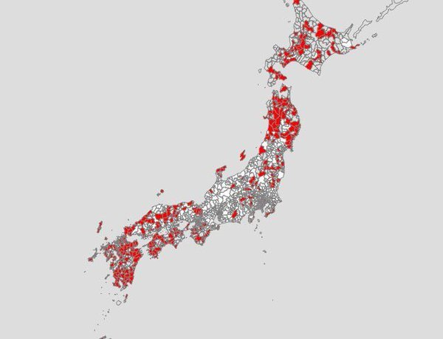](http://ameblo.jp/64152966/image-12124103135-13556194718.html)